AMRITSAR GROUP OF COLLEGES

**Autonomous status conferred by UGC under UGC act-1956, (2f), NAAC-A Grade,**

**(Formerly Known as Amritsar College of Engineering & Technology | Amritsar Pharmacy College )**

**Synopsis**

**On**

# “Cinema Booking System”

Submitted in the Partial fulfilment of the requirement for the Award of Degree of

# Bachelor of Technology

in

# COMPUTER SCIENCE & ENGINEERING

Batch (2020-24)

**Submitted To: Submitted By:**

Er. Ajay Sharma

Danish (2000091)

(Associate Professor) Kirti Sharma (2000128)

Jitendra Kr (2000116)

Jitendra Kr Sah (2000117)

# DEPARTMENT OF COMPUTER SCIENCE AND ENGINEERING

**Amritsar Group of Colleges, Amritsar**

|  |  |
| --- | --- |
| **Page No.** | **Topic Title** |
| 1 | Title of the project |
| **3** | Introduction of the Project |
| **4** | Abstract of the Project |
| **5** | Objective of the Project |
| **6** | Scope of the Project |
| **7** | Modules of the Project |
| **8** | Input data and validation of the project |
| **9** | Tools used in the Project |
| **10** | Tables used in the Project |
| **12** | Role/Task of each team member |
| **13** | Snapshots of the Project |
|  |  |
|  |  |
|  |  |
|  |  |
|  |  |
|  |  |
|  |  |
|  |  |
|  |  |
|  |  |
|  |  |
|  |  |

# Introduction of the Project Cinema Booking System:

The "Cinema Booking System" has been developed to override the problems prevailing in the practicing manual system. This software is supported to eliminate and in some cases reduce the hardships faced by this existing system. Moreover this system is designed for the particular need of the company to carry out operations in a smooth and effective manner.

The application is reduced as much as possible to avoid errors while entering the data. It also provides error message while entering invalid data. No formal knowledge is needed for the user to use this system. Thus by this all it proves it is user-friendly. Cinema Booking System , as described above, can lead to error free, secure, reliable and fast management system. It can assist the user to concentrate on their other activities rather to concentrate on the record keeping. Thus it will help organization in better utilization of resources.

Every organization, whether big or small, has challenges to overcome and managing the information of Tickets, Movie, Show Timing, Audi, Customer. Every Cinema Booking System has different Movie needs. This is designed to assist in strategic planning, and will help you ensure that your organization is equipped with the right level of information and details for your future goals.

# Abstract of the Project Cinema Booking System:

The purpose of Cinema Booking System is to automate the existing manual system by the help of computerized equipment and full-fledged computer software, fulfilling their requirements, so that their valuable data/information can be stored for a longer period with easy accessing and manipulation of the same. The required software and hardware are easily available and easy to work with.

Cinema Booking System, as described above, can lead to error free, secure, reliable and fast management system. It can assist the user to concentrate on their other activities rather to concentrate on the record keeping. Thus it will help organization in better utilization of resources. The organization can maintain computerized records without redundant entries. That means that one need not be distracted by information that is not relevant, while being able to reach the information.

The aim is to automate its existing manual system by the help of computerized equipment and full-fledged computer software, fulfilling their requirements, so that their valuable data/information can be stored for a longer period with easy accessing and manipulation of the same. Basically the project describes how to manage for good performance and better services for the clients.

# Objective of Project on Cinema Booking System:

The main objective of the Project on Cinema Booking System is to manage the details of Movie, Tickets, Booking, Show Timing, Customer. It manages all the information about Movie, Audi, Customer, Movie. The project is totally built at administrative end and thus only the administrator is guaranteed the access. The purpose of the project is to build an application program to reduce the manual work for managing the Movie, Tickets, Audi, Booking. It tracks all the details about the Booking, Show Timing, Customer.

## Functionalities provided by Cinema Booking System are as follows:

* Cinema Booking System also manage the Audi details online for Show Timing details, Customer details, Movie.
* It tracks all the information of Tickets, Audi, Show Timing etc.
* Manage the information of Tickets
* Shows the information and description of the Movie, Booking
* To increase efficiency of managing the Movie, Tickets
* It deals with monitoring the information and transactions of Show Timing.
* Manage the information of Movie
* Editing, adding and updating of Records is improved which results in proper

# Scope of the project Cinema Booking System

It may help collecting perfect management in details. In a very short time, the collection will be obvious, simple and sensible. It will help a person to know the management of passed year perfectly and vividly. It also helps in current all works relative to Cinema Booking System. It will be also reduced the cost of collecting the management & collection procedure will go on smoothly.

Our project aims at Business process automation, i.e. we have tried to computerize various processes of Cinema Booking System.

* + In computer system the person has to fill the various forms & number of copies of the forms can be easily generated at a time.
  + In computer system, it is not necessary to create the manifest but we can directly print it, which saves our time.
  + To assist the staff in capturing the effort spent on their respective working areas.
  + To utilize resources in an efficient manner by increasing their productivity through automation.
  + The system generates types of information that can be used for various purposes.
  + It satisfy the user requirement
  + Be easy to understand by the user and operator
  + Be easy to operate
  + Have a good user interface
  + Be expandable
  + Delivered on schedule within the budget.

# Modules of Cinema Booking System:

* Movie Management Module: Used for managing the Movie details.
* Customer Module : Used for managing the details of Customer
* Booking Module : Used for booking the tickets
* Movie earning Module: Used for managing the earnings of movie
* Login Module: Used for managing the login details
* Registration Module : Used for registering a customer.

# Input Data and Validation of Project on Cinema Booking System

* All the fields such as Movie, Booking, Registration are validated and does not take invalid values
* Each form for Movie, Tickets, Audi cannot accept blank value fields
* Avoiding errors in data
* Controlling amount of input
* Integration of all the modules/forms in the system.
* Preparation of the test cases.
* Modifications done for the errors found during testing.
* Functionality of the entire module/forms.
* Validations for user input.
* Checking of the Coding standards to be maintained during coding.
* Testing the module with all the possible test data.

# Tools Used in the Cinema Booking System

The tools used in the Cinema Booking system are (Tkinter) for frontend and Oracle database and SQL for backend .

## Tkinter:

Tkinter is the standard GUI library for python . Python when combined with Tkinter provides a fast and easy way to create GUI applications . Tkinter provides a powerful object oriented interface to the Tk GUI toolkit .

Creating a GUI application using Tkinter is an easy task . All you need to do is to perform the following steps –

* Import the Tkinter module.
* Create the GUI application main window .
* Add one or more widgets like label ,entry widgets or button to the GUI application.
* Enter the main event loop to take action against event triggered by the user.

## Oracle Database:

An Oracle Database (aka Oracle RDBMS) is a collection of data organized by type with relationship being maintained between the different types .The primary purpose of the database is to store and retrieve related information .

# Tables Used in Project:

* Password table for storing usernames and passwords of the customer



* Registration table for storing information about the customer.

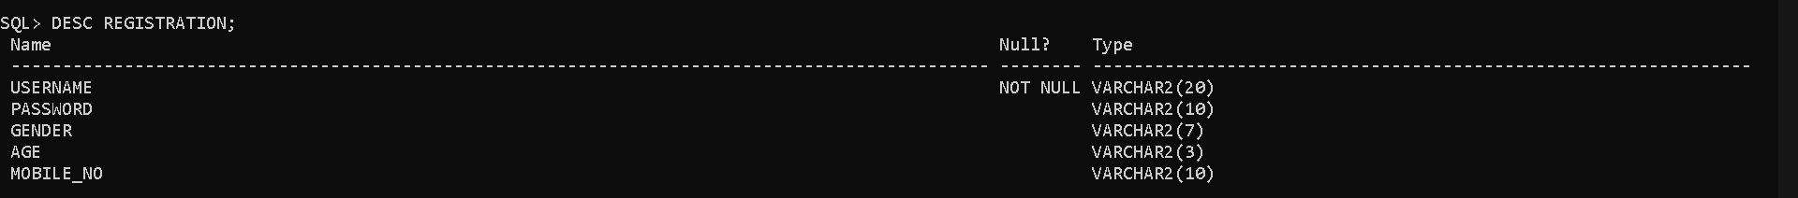

* Movie details table for managing movies

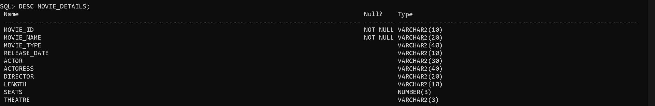

* Movie earnings table for managing movie earnings in the database.

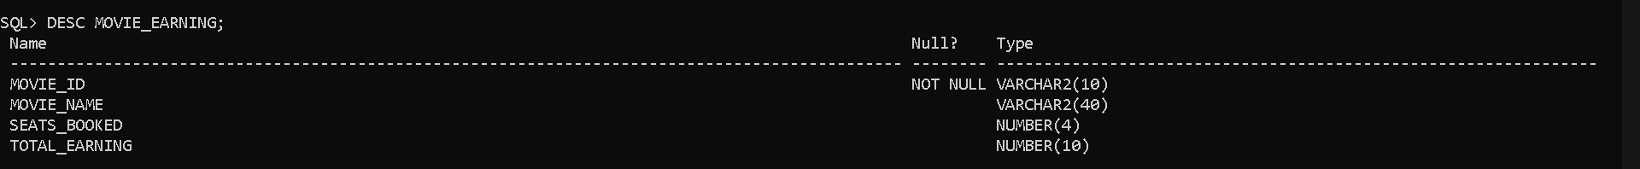

* Customer table for managing customers in the database

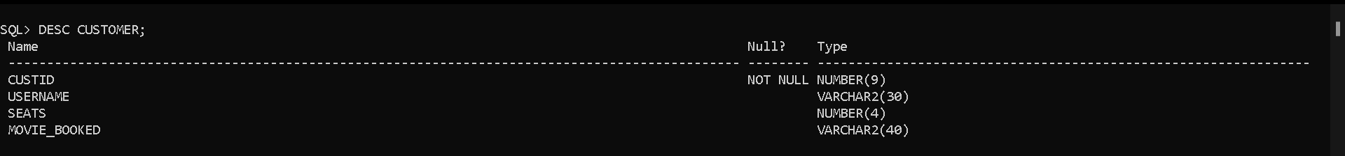

# Role of each Team member:

* Danish :- Creating User interface and managing backend.
* Kirti:- Creating Synopsis and Project Report
* Jitendra Kumar :-
* Jitendra Kumar Shah :-

# Snapshots of The Project:

